**Assignment Description:**

This document focuses on the development of user stories and use case diagrams for a location-based mobile application called Local History Explorer. The app is designed to offer users historical facts, images, and audio tours of nearby landmarks, enhancing their exploration experience. These deliverables aim to outline the core functionality and user interactions within the app.

1. Create a realistic *use-case diagram*containing at least **4 actors**and at least **10 use cases**(functional requirements).

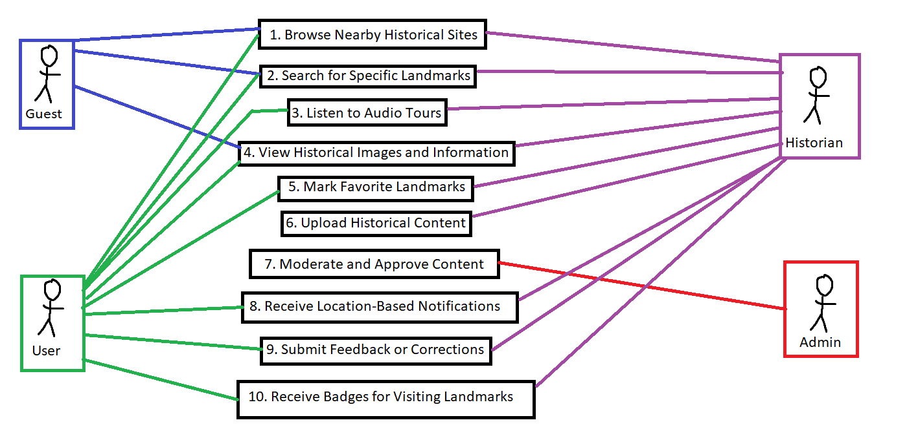

1. Create 10 user stories based on rules discussed on the seminar (it should use the recommended template and it should have **well defined acceptance criteria**(s)).
2. **As a** User,  
   **I want to** browse nearby historical sites,  
   **In order to** easily discover landmarks based on my current location.

**Acceptance Criteria:**

* The app must display a list of historical sites within a 5 km radius of the user's current location.
* Each site must include a thumbnail image, brief description, and distance from the user.
* Users should be able to filter sites by category (e.g., museums, battlefields).
* Map integration should allow users to view locations on a map.

1. **As a** User,  
   **I want to** search for specific landmarks,  
   **In order to** quickly find information about a site I’m interested in.

**Acceptance Criteria:**

* The search function should accept queries by landmark name, type, or location.
* Search results must include relevant sites, their descriptions, and locations.
* Results must update dynamically as the user types.

1. **As a** User,  
   **I want to** listen to audio tours related to historical landmarks,  
   **In order to** have an immersive experience while exploring a location.

**Acceptance Criteria:**

* The app must allow users to play, pause, and skip audio for landmarks.
* Audio should automatically start when a user approaches a designated location.
* Audio player controls should remain accessible on the screen while touring.

1. **As a** User,  
   **I want to** view historical images of landmarks,  
   **In order to** visually connect with the history of the location.

**Acceptance Criteria:**

* Each historical site page must feature at least 3 high-quality images.
* Images should include captions with brief historical explanations.
* Users must be able to zoom in and swipe between images.

1. **As a** User,  
   **I want to** mark landmarks as favorites,  
   **In order to** easily access them later during my visit.

**Acceptance Criteria:**

* Users must be able to mark any site as a favorite by clicking a heart icon.
* A “Favorites” tab should list all saved sites.
* Users should be able to remove sites from favorites.
* Favorite landmarks must sync across multiple devices when logged in.

1. **As a** Historian,   
   **I want to** upload historical facts, images, and audio tours,  
   **In order to** contribute valuable information for users exploring local history.

**Acceptance Criteria:**

* The app should provide a content upload form with fields for text, images, and audio files.
* All uploads must be reviewed by an administrator before going live.
* The upload form must include fields for historical references and metadata (date, location, etc.).
* The form should only be available for users registered as Historians.

1. **As an** Administrator,  
   **I want to** moderate content before it's published,  
   **In order to** ensure that all information is accurate and appropriate.

**Acceptance Criteria:**

* The system must flag new content for review before publishing.
* Administrators must have options to approve, edit, or reject submissions.
* Rejected content must include feedback for the uploader on why it was rejected.
* Administrators should be notified of new content pending approval.

1. **As a** User,  
   **I want to** receive notifications when events are happening at nearby historical sites,  
   **In order to** stay informed about live activities, tours, or exhibitions.

**Acceptance Criteria:**

* Notifications must trigger when the user is within a 500-meter radius of a historical site hosting an event.
* Notifications must display the event name, date, time, and a brief description.
* Users must have the option to tap the notification to view more details or dismiss it.
* Users must have the ability to enable or disable event-based notifications in the app’s settings.

1. **As a** User,  
   **I want to** submit feedback on the accuracy of information,  
   **In order to** help improve the content quality on the app.

**Acceptance Criteria:**

* Users must have an option to submit feedback directly from each historical site’s page.
* Feedback form must include options for rating accuracy, submitting corrections, and suggesting additional content.
* Administrators should receive notifications of new feedback submissions.

1. **As a** User,  
   **I want to** access downloaded historical content offline,  
   **In order to** explore landmarks without needing an active internet connection.

**Acceptance Criteria:**

* Users must be able to download entire tours, including audio and images, for offline access.
* Offline mode must allow access to all previously downloaded content.
* Users should be notified when they enter or leave offline mode due to network conditions.